David Allen

G00375372

Week 6

**Contains**: Assignment 5A - Release planning/Sprint planning/Initial execution and artifacts

**Team Blade Runner**:

**Scrum Master** - Ion Cirnici G00374920

**Product Owner** – Luke Byrne G00373744

**Software Engineer** – David Allen G00375372

**Software Engineer** – Sam Brownless G00260547

**Product Tester** – Ammad Aslam G00365389

Blade Runner

Project Management

Contents

Agile Release Plan 2

Release Planning 2

Sprint Goals 2

Sprint Plan 3

Confidence Vote 4

Scrum/Task Board 5

Jira / Additional info 5

Release/Product Burndown chart 6

The sprint begins 6

References 6

# Agile Release Plan

The project release duration will comprise of 2 sprints, over a duration of 4 weeks. Each sprint will be 2 weeks long each.

Sprint 1 and 2 are scheduled below as:

* Sprint 1: Monday 17th February – Friday 28th February
* Sprint 2: Monday 2nd March – Friday 13th march

## Release Planning

Before we could start the first sprint of the project, we had to have a meeting to set priority of certain tasks and decide which ones should be completed in what order. As a team the product owner and development team came together to organise this.

The user stories were prioritized by the product owner from the product backlog. Each user story was gone through and given highest priority to lowest priority based on what was most important for the website. As per the product owner’s recommendations, it was discussed amongst the team and agreed upon that all stories were to be included over both sprints and the priority of each user story was important and gave the team short goals to work towards.

## Sprint Goals

All user stories from the product backlog were committed to the sprint backlog. It was determined that all user stories would be accepted but only completed once they adhered to our definition of ready.

The overall sprint goal is to create a website which allows customers to browse and book a table. To provide recommendations and keep the customer up to date with new and upcoming events.

A shorter goal for sprint one would be to commit to the sprint plan of 5 user stories and keep within the scheduled timeframe. This encourages the team to work towards an achievable goal and stay motivated.

## Sprint Plan

The team velocity is an important part of planning the release of the project. Previously the team had sized all user stories, which helps in determining the velocity, the amount of work in the sprint, the possible time required to get each story completed and how many stories the team can commit to.

Initially we took all our user stories and tallied them up. 11 stories, incorporating a total of 23 pints in story sizing. So, we had an idea to break them down in half for each sprint, meaning an average of 12 points per sprint. We drew up a release plan on the whiteboard and moved the user stories over in priority. Settling on 5 user stories and 11 story points for the first sprint. We considered an additional user story but didn’t think it would be wise to push for 13 story points in one sprint, as we didn’t believe we could fit the work in with our chosen velocity. Although it left 6 user stories and 12 story points for the second sprint, which is within our scope for the release deadline.

## Confidence Vote

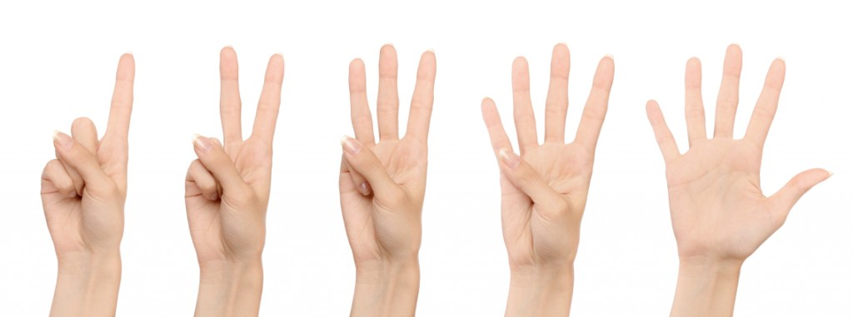  
[Ref A.]

During our meeting on the 17th of February we held a confidence vote. This was to define how confident each of us as members of the development team were in the project and how positive or negative, we felt about the project. It would enable the team to agree to do everything reasonable within their power to meet the committed objectives.

For the confidence vote the team researched techniques that were fair and worked within scrum. A technique known as the [Ref B.] Fist of Five was discovered. Fist of Five is a quick way of gaining feedback from all member and gauge the confidence of the team. It allows a quick change to the planning or commitment if necessary.

To carry this out in the most straightforward manner we wrote our level of confidence on our hands, 1-5, 1 being extremely negative and 5 being positive, we then displayed our numbers as a team. Four out of five members of the team voted a 5 out of 5 with only one member showing doubt but still voting a four so the team member only had a small level of doubt in the project. To resolve this, we addressed their doubts through discussion. Following discussion, we found their reason of doubt to be manageable as they were afraid of other obligations which would not allow for time to complete the project. After further discussion we came to the agreement that it would in fact be achievable and that certain tasks would be moveable to the next sprint if required.

## Scrum/Task Board

Each user story was reviewed and broken down into smaller, more manageable tasks. It allows each member to divide tasks between the team and update the task status. A visual representation is always best. Each task is seen clearly, and a member can commit. You can see tasks not started, to tasks that are being worked on and tasks that are completed.

All tasks will be documented for reference of what team member did what and how t was achieved. The task board will aim to be updated at each scrum, to see changes that are made and what tasks are left to be completed.

## Jira / Additional info

All information is updated to Jira for a digital version. Although our team prefers most work be done on the whiteboard. Tasks are easier when all information is visible to the team, not to mention when all member are working in front of the whiteboard communication is better and work tends to be more efficient. Working with post it notes and a marker enables the team to see evidence of their progress and is more personnel than looking at a computer screen.

## Release/Product Burndown chart

A burndown chart was created to show the effort made over the 2 sprint iterations. At this moment the chart shows a normal curve of completion of each task with no complications. If any difficulty arises, the chart will show a big fat lie as the effort for each task is unknown and only time will tell if our estimates are accurate.

An initial burndown chart will be recorded and show more accurately how each task is completed, the actual effort used and the amount if work remaining.

## The sprint begins

With the release plan completed, the sprint begins.

## References

Ref A + B. Image and information

Green, P. (2020). *Using the Fist of Five technique to gauge confidence*. [online] Agile @ Adobe. Available at: https://blogs.adobe.com/agile/2013/12/17/using-the-fist-of-five-technique-to-gauge-confidence/ [Accessed 16 Feb. 2020